***AIDS MICROPROCESSOR LAB S21 BATCH (2023-24)***

***Experiment 13 Title: Program and interfacing using 8255.***

***Name of student: Meet Raut Class Roll Number: 2201084***

***Date of Performance: 01/04/2024***

***Batch: S2-1 Timing: 3:00-5:00 Date of Submission: -01/04/2024***

***Assembly language code***

*DATA SEGMENT*

*DISP DB 3FH,06H,5BH,4FH,66H,6DH,7DH,07H,7FH,6FH ; Define an array of display codes*

*DATA ENDS*

*CODE SEGMENT PUBLIC 'CODE'*

*ASSUME CS:CODE, DS:DATA*

*START:*

*; Initialize data segment register DS with the base address of the data segment*

*MOV AX,DATA*

*MOV DS,AX*

*; Initialize DX with the port address for output*

*MOV DX,06H*

*; Enable display*

*MOV AL,80H*

*OUT DX,AL*

*; Initialize DI register with the offset address of DISP array*

*MOV DI,OFFSET DISP*

*; Clear DX register for port access*

*MOV DX,00H*

*; Output the first character from DISP array to the display*

*MOV AL,[DI]*

*MOV DX,00H*

*OUT DX,AL*

*; Initialize loop counter for displaying multiple characters*

*MOV BH,0AH ; BH will control the number of characters to display*

*D_LOOP:*

*; Load loop counter with maximum count value*

*MOV CX,0FFFFH*

*; Inner loop to delay display*

*AGAIN:*

*LOOP AGAIN*

*; Move to the next character in DISP array*

*INC DI*

*; Output the character to the display*

*MOV AL,[DI]*

*OUT DX,AL*

*; Decrement loop counter and continue until all characters are displayed*

*DEC BH*

*JNZ D_LOOP*

*; Infinite loop to keep the program running*

*ENDLESS:*

*JMP ENDLESS*

*CODE ENDS*

*END START*

*Result:*

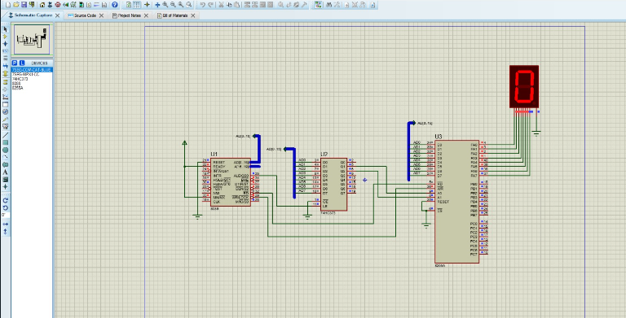

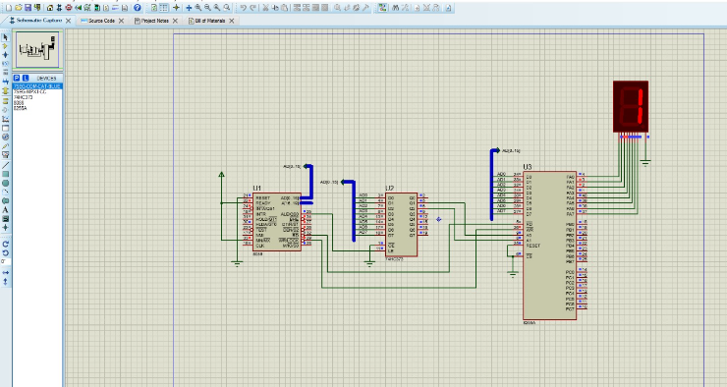

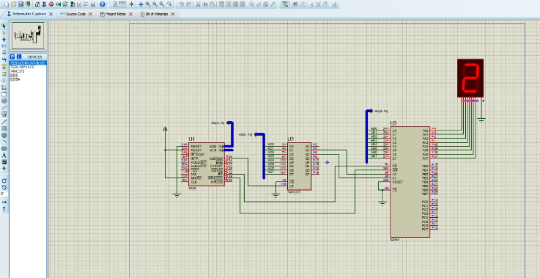

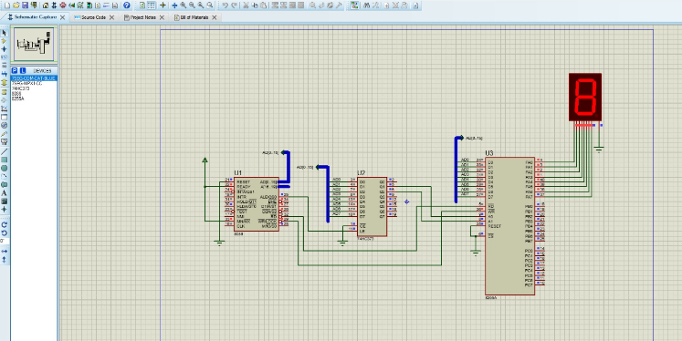

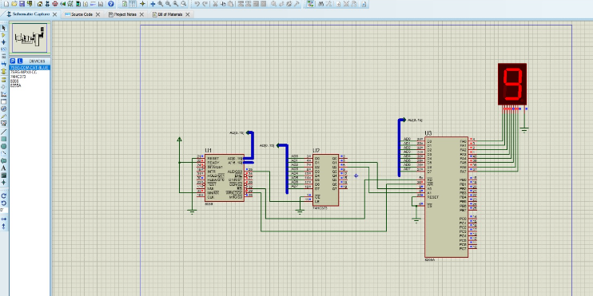

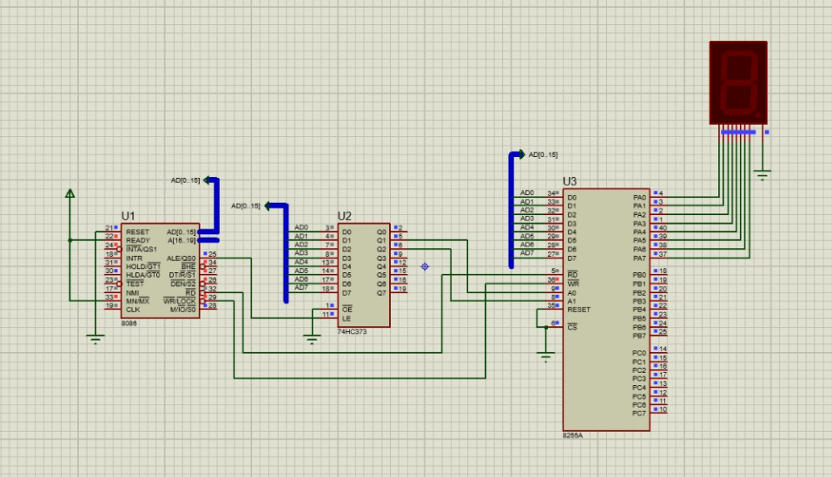

*CONCLUSION: LO 2, LO 3 mapped.*

***---------------------------------*****************************-----------------------------------***